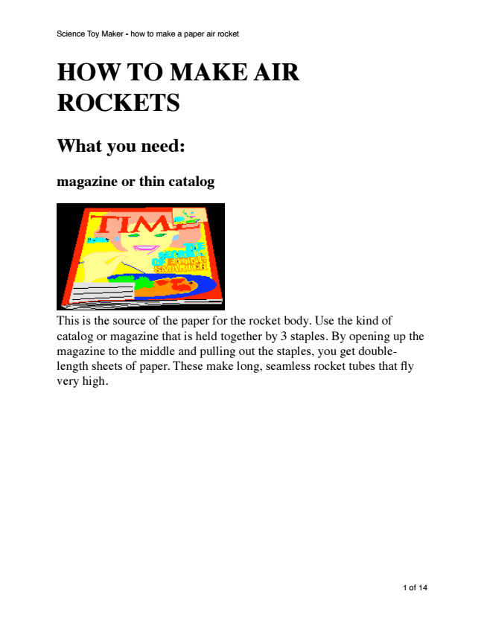
HOW TO MAKE AIR ROCKETS
What you need:
magazine or thin catalog
Science Toy Maker - how to make a paper air rocket
This is the source of the paper for the rocket body. Use the kind of catalog or magazine that is held together by 3 staples. By opening up the magazine to the middle and pulling out the staples, you get double- length sheets of paper. These make long, seamless rocket tubes that fly very high.
1 of 14
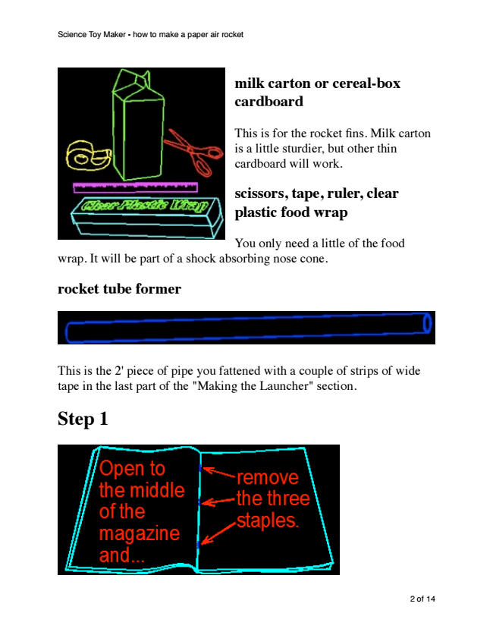
milk carton or cereal-box cardboard
This is for the rocket fins. Milk carton is a little sturdier, but other thin cardboard will work.
scissors, tape, ruler, clear plastic food wrap
You only need a little of the food wrap. It will be part of a shock absorbing nose cone.
rocket tube former
This is the 2' piece of pipe you fattened with a couple of strips of wide tape in the last part of the "Making the Launcher" section.
Step 1
Science Toy Maker - how to make a paper air rocket
2 of 14
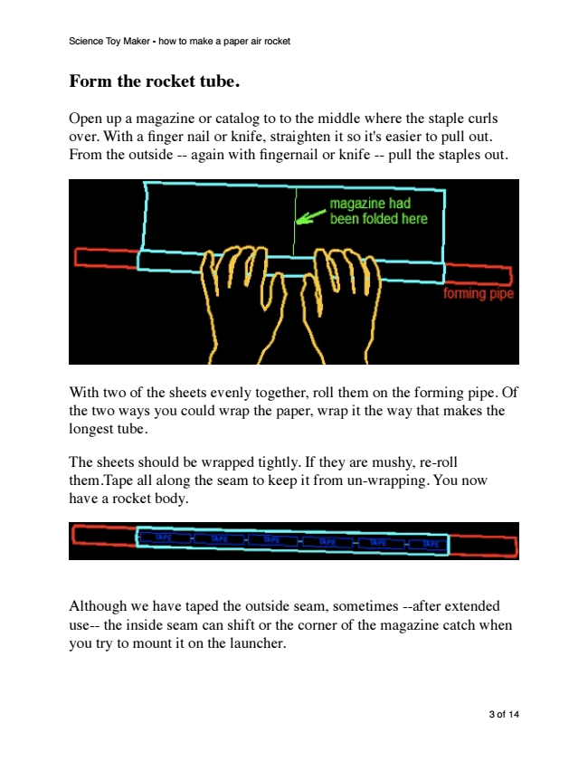
Form the rocket tube.
Open up a magazine or catalog to to the middle where the staple curls over. With a finger nail or knife, straighten it so it's easier to pull out. From the outside -- again with fingernail or knife -- pull the staples out.
With two of the sheets evenly together, roll them on the forming pipe. Of the two ways you could wrap the paper, wrap it the way that makes the longest tube.
The sheets should be wrapped tightly. If they are mushy, re-roll them.Tape all along the seam to keep it from un-wrapping. You now have a rocket body.
Science Toy Maker - how to make a paper air rocket
Although we have taped the outside seam, sometimes --after extended use-- the inside seam can shift or the corner of the magazine catch when you try to mount it on the launcher.
3 of 14
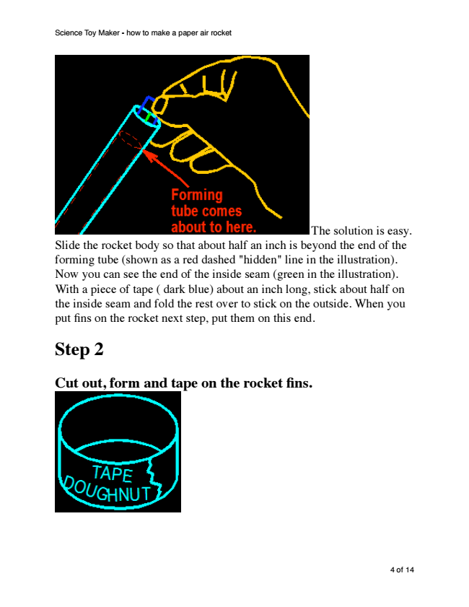
The solution is easy. Slide the rocket body so that about half an inch is beyond the end of the forming tube (shown as a red dashed "hidden" line in the illustration). Now you can see the end of the inside seam (green in the illustration). With a piece of tape ( dark blue) about an inch long, stick about half on the inside seam and fold the rest over to stick on the outside. When you put fins on the rocket next step, put them on this end.
Step 2
Cut out, form and tape on the rocket fins.
Science Toy Maker - how to make a paper air rocket
4 of 14
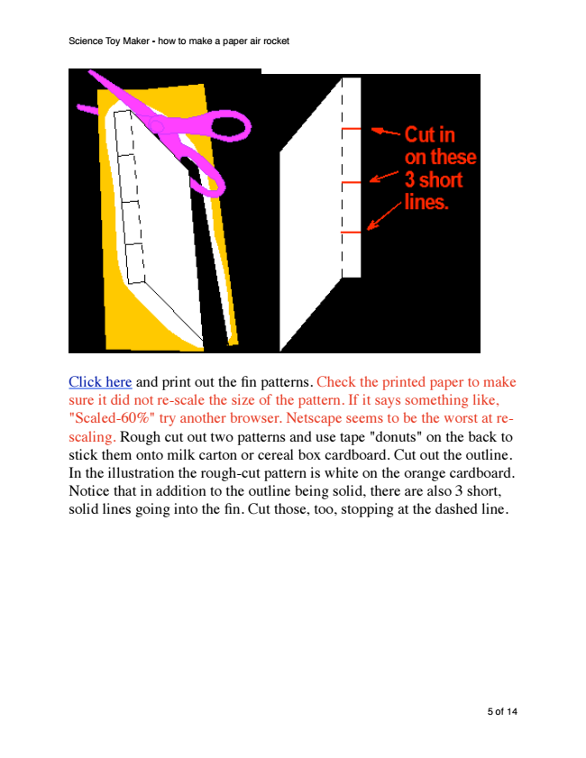
Science Toy Maker - how to make a paper air rocket
Click here and print out the fin patterns. Check the printed paper to make sure it did not re-scale the size of the pattern. If it says something like, "Scaled-60%" try another browser. Netscape seems to be the worst at re- scaling. Rough cut out two patterns and use tape "donuts" on the back to stick them onto milk carton or cereal box cardboard. Cut out the outline. In the illustration the rough-cut pattern is white on the orange cardboard. Notice that in addition to the outline being solid, there are also 3 short, solid lines going into the fin. Cut those, too, stopping at the dashed line.
5 of 14
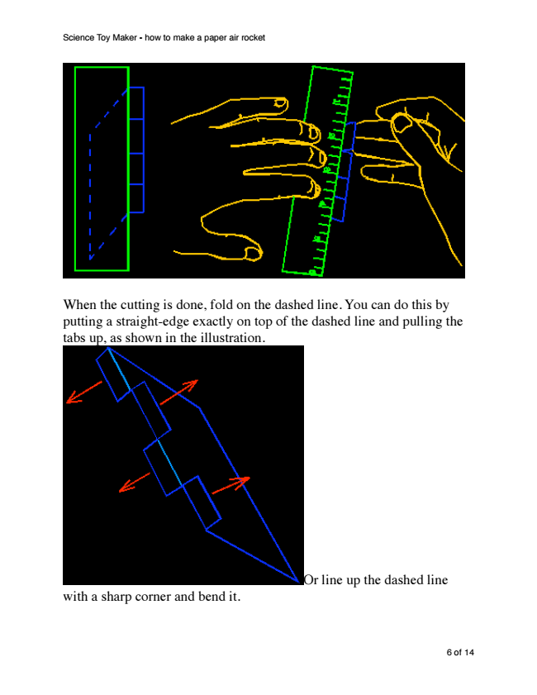
When the cutting is done, fold on the dashed line. You can do this by putting a straight-edge exactly on top of the dashed line and pulling the tabs up, as shown in the illustration.
Science Toy Maker - how to make a paper air rocket
Or line up the dashed line with a sharp corner and bend it.
6 of 14
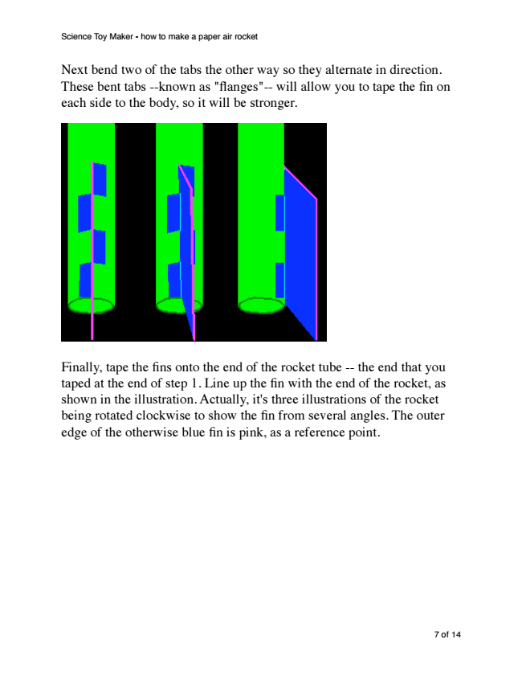
Next bend two of the tabs the other way so they alternate in direction. These bent tabs --known as "flanges"-- will allow you to tape the fin on each side to the body, so it will be stronger.
Science Toy Maker - how to make a paper air rocket
Finally, tape the fins onto the end of the rocket tube -- the end that you taped at the end of step 1. Line up the fin with the end of the rocket, as shown in the illustration. Actually, it's three illustrations of the rocket being rotated clockwise to show the fin from several angles. The outer edge of the otherwise blue fin is pink, as a reference point.
7 of 14
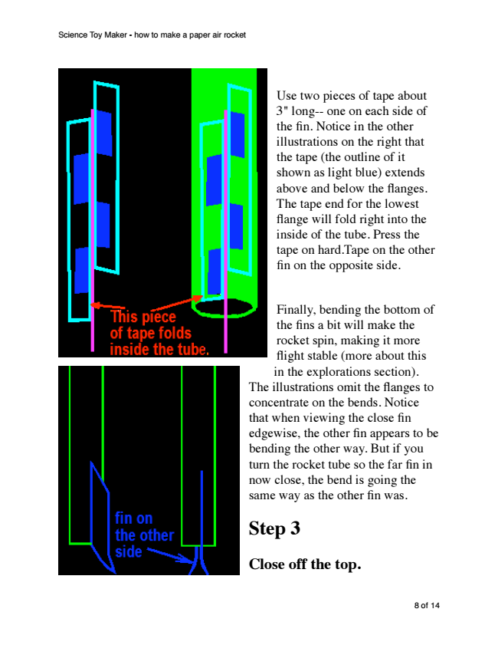
Science Toy Maker - how to make a paper air rocket
Use two pieces of tape about 3" long-- one on each side of the fin. Notice in the other illustrations on the right that the tape (the outline of it shown as light blue) extends above and below the flanges. The tape end for the lowest flange will fold right into the inside of the tube. Press the tape on hard.Tape on the other fin on the opposite side.
Finally, bending the bottom of the fins a bit will make the rocket spin, making it more flight stable (more about this in the explorations section). The illustrations omit the flanges to concentrate on the bends. Notice that when viewing the close fin edgewise, the other fin appears to be bending the other way. But if you turn the rocket tube so the far fin in now close, the bend is going the same way as the other fin was.
Step 3
Close off the top.
8 of 14
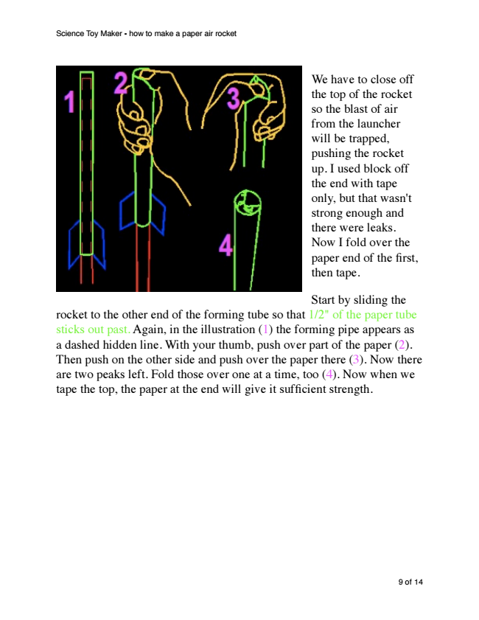
We have to close off the top of the rocket so the blast of air from the launcher will be trapped, pushing the rocket up. I used block off the end with tape only, but that wasn't strong enough and there were leaks. Now I fold over the paper end of the first, then tape.
Start by sliding the rocket to the other end of the forming tube so that 1/2" of the paper tube sticks out past. Again, in the illustration (1) the forming pipe appears as a dashed hidden line. With your thumb, push over part of the paper (2). Then push on the other side and push over the paper there (3). Now there are two peaks left. Fold those over one at a time, too (4). Now when we tape the top, the paper at the end will give it sufficient strength.
Science Toy Maker - how to make a paper air rocket
9 of 14
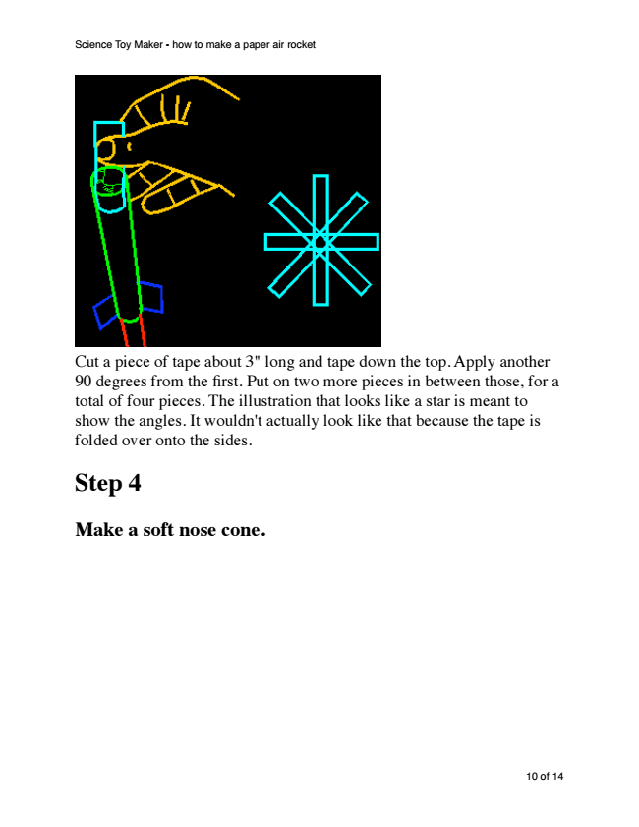
Science Toy Maker - how to make a paper air rocket
Cut a piece of tape about 3" long and tape down the top. Apply another 90 degrees from the first. Put on two more pieces in between those, for a total of four pieces. The illustration that looks like a star is meant to show the angles. It wouldn't actually look like that because the tape is folded over onto the sides.
Step 4
Make a soft nose cone.
10 of 14

