Science 9 Ainsley
June 8, 2017
Principles of Learning Post

What is interconnectedness?
Interconnectedness is the state of being connected with each other. They might be connected in many ways, whether it’s spiritually, emotionally, or physically. For example in this unit we learned about food chains, food webs and the different type of consumers from the primary producers to tertiary consumers. The different types of consumers rely on each other to survive and if you break apart the food chain or food web then some of the consumers might die and the food chain/web will be all messed up. Another example would be the water cycle. We need water to survive and water gets recycled.
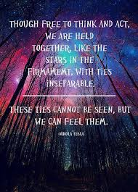
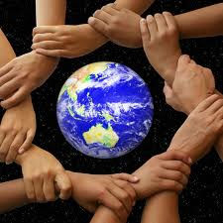

What is sustainability?
Sustainability is the study of how natural systems function and produce everything it needs for the ecology to remain in balance. Also, another definition of it is how we can sustain and keep our environment healthy to pass down to the future generations. If people can’t keep the environment clean, bad things will happen such as global warming. For example if we cut down trees then we will lose some of our fresh air because trees produce oxygen. Also, another problem is pollution. Every time someone drives a car it releases pollution into the air. Some ways to reduce pollution are conserve energy, for example remember to turn off lights, computers, and electric appliances when not in use. Also, try using fewer things that are harmful to our world and use energy efficient light bulbs and appliances.

