Foods 10 Ainsley
June 7, 2017
Junk Food
Wendy’s
Menu Item: Junior Cheese Burger Deluxe.
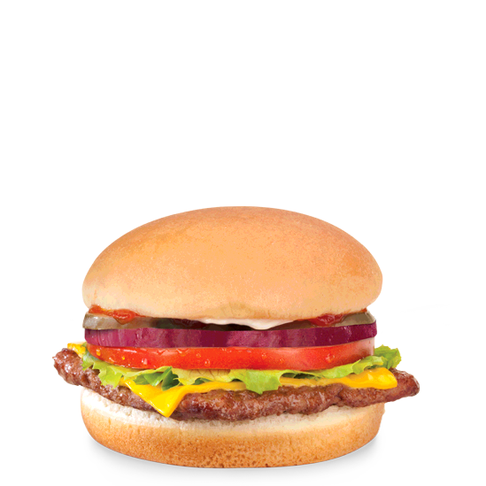

Description- 100% square beef patty with a fluffy white bun. Topped off with a ketchup mayonnaise sauce with cheese, pickles, onions, tomatoes and lettuce.
This is not healthy for me because...
- It has over 35% of the daily max of sodium
- Saturated fat is the worst type of fat and this burger has 7g of it.
- It is highly processed

