Experimental Inquiry Project

You will be working with a partner to conduct an experiment over the next several weeks. You will hand in a lab write up written in paragraphs and including any charts necessary to answers the questions below. Your topic will include experimenting on how altering an abiotic factor (not alive) can influence a biotic (alive) factor. This topic must also relate to an environmental issue. For example –

How much organic waste can worms eat?
Can plants stop erosion?
How does acid rain affect fish?

You may create your own project our use one already created. This site has great ideas:
http://www.sciencebuddies.org/science-fair-projects/Intro-Environmental-Science.shtml

One plant with coke and one plant with Pepsi

- Question and Predict
Draft Due: May 16, 2017
- Create a question.
(Does Coke or Club Soda affect the growth of a plant?)
- Predict multiple answers.
Some of the multiple answers could be The plant could die, The sugar could act like salt and prevent the plant from absorbing water, The plant might not die but it could grow, The plant could become dehydrated

- Formulate multiple explanations/reasons for those answers (hypotheses).
The sugar content of Coke, which changes the concentration of the soil and can make it hard for the plants to absorb water. Also, the plants can’t absorb sugar since plants create their own sugars through photosynthesis. Carbonated water contains macronutrients that are essential for healthy plant growth. The inner layer of tissue in the branching roots that anchor the plant is sensitive to salt and activates a stress hormone, which stops root growth. Coke has a dropping 3.38 grams of sugar per ounce, which could kill the plant as it would certainly be unable to absorb water and nutrients.

- Planning and Conducting Draft Due: May 17, 2017
- Plan an investigation.
Answer: We are trying to investigate if plants will grow using soda which is sugary instead of water.
- Address ethical, cultural and/or environmental issues.
Answer: Some environmental issues are that people pour drinks into plants.
- What equipment will you use to collect and record data? (Digital technology, microscope etc.)
Answer: For our experiment we will need to get six small plants, one bottle of Coke, one bottle of Club Soda and we will need a phone to take pictures in between our experiment.

- What safety concerns or risks are present?
Answer: One of the safety concerns is mold because it could form due to the sugary content and mold is very bad for people.

- Processing and analyzing data and information Draft Due: June 13, 2017
- Consider First Peoples perspectives and knowledge gained from other subject areas.
Answer: We think that First Peoples perspectives are that we should nurture our children so they can feel safe growing and at home. So, consider that perspective of First People, we were kind of nurturing the plants and trying to take care of them so they can grow.
- Construct visuals - graphs, models and/or diagrams to represent the data you have collected.
Answer: Our graph is on a blank piece of paper.
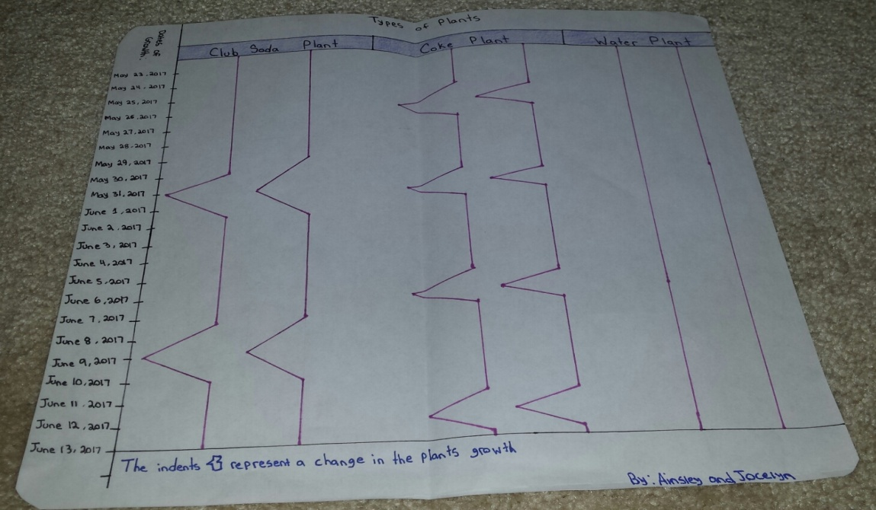

- Analyze and interpret the graphs/models/diagrams.
Answer: The graph represents the changes in growth during our experiment. The indents on the graph represent the plant losing growth like drying, losing leaves or dying. Also, the graph shows that the water plant had no changes to the Club Soda plant having little to no changes.
- Describe the relationship between the variables.
Answer: The relationships between the plants are how the water plant has no changes in contrast to the Coke plant that has multiple changes happening rapidly with no stop. Finally, the Club Soda has minimal changes.
- Explain any inconsistencies you see.
Answer: The Coke plant died because of all the sugar it has in it and because of the heat. Also, the Club Soda plant was partially dead and partially alive.

Evaluate/ Conclude
Yes, our findings support our hypothesis, because we said that the Coke plant would have a lower chance of living since the roots can’t absorb sugar. Plants create their own sugar through photosynthesis. Club Soda is carbonated water, and it has no sugar so the plant would absorb some liquid. The plain water plants were the most successful out of the six different plants.
The sources of error or uncertainty for us were that we watered the plants every second day instead of watering them every single day. Another source of error for us were that we left our plants in the direct sunlight over the weekend instead of moving them somewhere cooler where the plants could have some shade.
Some ways we could have improved our experiment was to be more prepared, and pick a better location for our plants, so they were not in the scorching hot sun. We also did not know how much water / coke to put in each plant, so we were not consistent with the amount we put in every second day. So we should have measured the amount of liquid we put in each time. Secondly, we should have watered the plants every day, although we were unable to do that over the hot weekend. Lastly we should have gotten some plant holders, so they would hold all the soil and water in.
In conclusion, we knew that the Coke plant was going to die, but we did not expect it to happen so rapidly. At first our experiment was going well, but during the second week we had unusually high temperatures (33 degrees) and our plants were directly in the sunlight. Due to this excess heat our plants did not survive and they dried out over the weekend. When we came back to school we tried watering them twice as much but unfortunately the damage had been done, and it was irreversible.

