Foods 10 Ainsley
June 2, 2017
Chili Cook off Reflection

The members in my group were Ethan, Soyi, and Henry.

Our group made a Spicy Chili that included tomatoes, two types of beans (Kidney and Black), one Onion, two Red Peppers, Chili Powder, Ground Beef, Tomato Paste and Spices. Also, our group added some hot sauce to spice up the Chili even more.

We started off day one by researching creative chili recipes that would work for our group. Our group wanted to do something that was unique, different and easy. We found a couple of recipes that we really liked, but we were unable to use them because the recipes took between two and three hours to make. We only had an hour to an hour and 10mins to make our chili.

After searching a bit more we found a recipe that sounded good, and looked pretty simple to prepare. We altered the recipe a little bit by adding hot sauce to make the chili even more spicy and tangy. Once we found our recipe we had to convert it from imperial to metric, and we had to work together to finish the chili cook-off outline.

On day two we had a demo lab for the cheese braid that would accompany the chili. After the demo we prepared all of our ingredients so they would be ready the next day, and we wouldn’t have to waste any time.

Day three was the second to last day of the competition. Day three was the day that we cooked our chili and taste tested it. When we were getting everything ready to cook we realized that we only had 100 grams of ground beef, and the recipe called for 800 grams. So we had to shrink our recipe. Also, when we were making our chili we noticed that it was really liquidy and it was more like soup then chili. So we asked Mr. Brett and he suggested that we should add some tomato paste to thicken it up. When Soyi taste tested it she said “it was good, it had lots of flavour, and had lots of tomatoes”. At the end of the day there were lots of dishes, and spills that our group had to clean up.

Day four was the cook-off day. We took our chili out of the fridge, put it in a pot, and placed it on the element to warm it up. After that we mixed our ingredients for the cheese braid. Once we were done making the dough we rolled them, braided them, and then popped them into the oven for 16 minutes. Then after everything was done cooking it was time to plate our chili and present it!!!

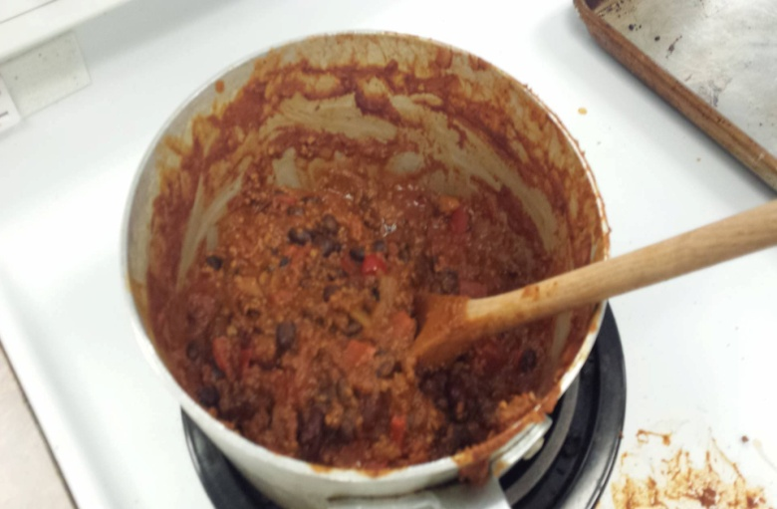
In conclusion, the chili cook-off went pretty well and was a lot of fun!

