Quick Cinnamon Rolls
Yield: 18
Ingredients
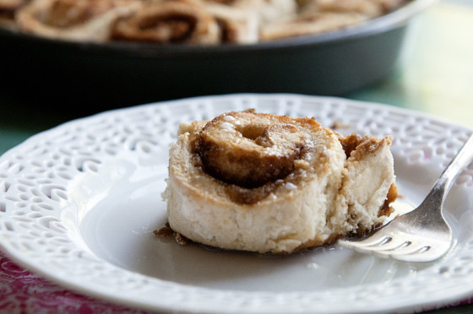
Dough:

- 250ml of flour

- 15ml of sugar (substituted with Brown Sugar)

- 10ml baking powder

- 5ml of salt

- 30ml of butter

- 150ml of milk

Filling:
- 30ml of butter
- 125 ml of sugar
- 15ml of cinnamon (substituted with nutmeg)

Glaze:
- 125ml of powdered sugar
- 100ml of milk

Method
- For the filling, in a small bowl combine softened butter, brown sugar and cinnamon to
form a crumbly mixture.

- Sprinkle 1/2 of the mixture over the bottom of a 9x9 pan.
- In a large bowl mix together flour, sugar, baking powder, and salt.
- Cut in softened butter (sometimes your hands are the best tools).
- Stir in milk to form a soft dough.
- Roll out dough on a lightly floured into a rectangle about 1/4 inch thick.
- Spread the remaining filling on the rolled out dough.
- Roll up the rectangle, with a sharp knife slice into 18 small rolls (12 if you want them a little bigger).
- Bake for 20-25 min at 400°F.
- For glaze, combine powdered sugar and milk in a small bowl and stir until smooth.
- Once rolls are finished, drizzle on glaze and serve warm.

