Foods 10 Ainsley
April 20, 2017
Salad Rolls

Question: Did you enjoy this lab? Why or why not?
Answer: Yes I enjoyed this lab because it was something different and it was challenging to roll the rice paper.

Question: What reasonable (i.e. no candy!) thing would you do to alter this recipe to keep it healthy or make it healthier? What nutritional value would this add to the recipe (i.e. carbohydrates, protein, vitamins, minerals, fats)?
Answer: I would add different types of vegetables and cook them to make them softer, such as corn which would provide you with vitamin B and C. I would also substitute the shrimp for chicken. Chicken is a good supply of protein content and the supply of essential vitamins and minerals.

Question: Often, rolls like these are served deep fried. Most people understand that deep frying food is not healthy for us. What exactly does deep frying do to our food? Why does it become unhealthy? What, if any, nutrients are added that are not great for us?
Answer: Deep frying cooks the food faster and adds extra fats. When you deep fry things they become insanely greasy which is not healthy for you.
‘Fried foods are unhealthy because they are high in fat, calories and sodium. But, deep frying also robs food of nutrients.’ If you don’t eat too much sodium and fatty foods then maybe once in a while you could eat deep fried foods. But if you eat lots of fatty foods then maybe stay away from deep fried foods.
Sources:
http://www.fitday.com/fitness-articles/nutrition/healthy-eating/food-myths-debunked-fried-foods-are-too-fatty-and-unhealthy.html

Mise - en- Place
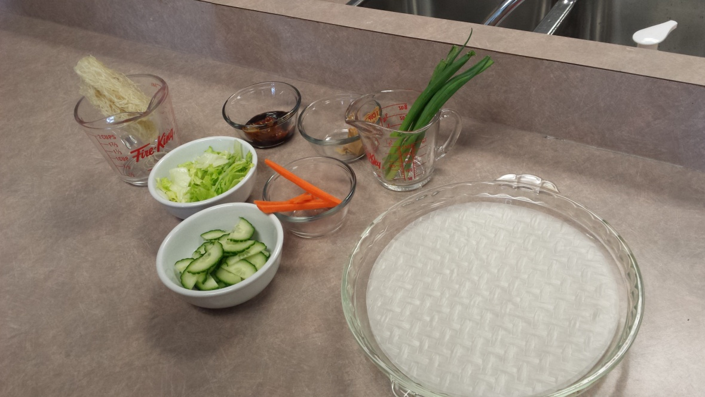

Final Product
