Take Your Kid To Work Day

Student Name: Ainsley Enos
RAP: A50
Class: Mrs. Della

Name Of your host: Derek Enos
Relationship to you: Father

Interview
- Q: What is your job title?
A: Chief of Information Technology Client Services- Correctional Services (CSC)/ Parole Board of Canada (PBC)

- Q:What is your job description?
A: Information Technology (IT) support for the two sites listed above in question #1

- Q: What are the duties and/or tasks you preform at your job?
A: To provide Information Technology support to the Pacific PBC office and CSC Regional staff College
- Install, configure, maintain all computers and electronics
- Troubleshoot and diagnose network and communications problems
- Troubleshoot and support all staff at these two sites

- Q: What qualifications do you have for this job in the following areas:
- Training? 20 years on the job experience with many technical courses taken in that time
- Education? Computer information systems diploma from Douglas College
- Experience? I have worked in the Federal Government IT for a number of different departments over my 21 years in the government
- Skills & attributes (personal qualities)? Along with all the technical skills required for my job, one of the most valuable skills is having the soft skills to deal with clients in a technical support role. Sometimes it is in person other times it can be over the phone with people across the country

- Q: What are some of the things you like about your job?
A: I like working with different people and the variety of issues that I encounter each day. Also, when you can help a frustrated person it is very satisfying.

- Q: What are some of the things you dislike about your job?
A: One thing I dislike about this job is the slowness in the processes. Sometimes that slows me down at doing my job.

- Q: How do you anticipate this job changing in the next five years or so?
A: I anticipate changes in the next five years with the continued push to shared services within the Federal Government for the better or worse. Shared Services Canada is taking over a lot of the services and trying to centralize them.

Student Reflections
- Q: Give three reasons why you would like this job:
A: - Variety in tasks
- Quiet
- Involves hard work and skills

- Q: Give three reasons why you would not like this job:
A: - Technology/ IT doesn’t entrust me as much as my dad
- The loneliness
- Having to know so many different technologies

- Q: Is this job for you? Why or why not?
A: This job is not for me because it is pretty boring and does not catch my interest.

- Q: Explain the value of the TOKTW experience in relation to your ideas about your post secondary plans?
A: Lets me see what it is actually like to have a job.

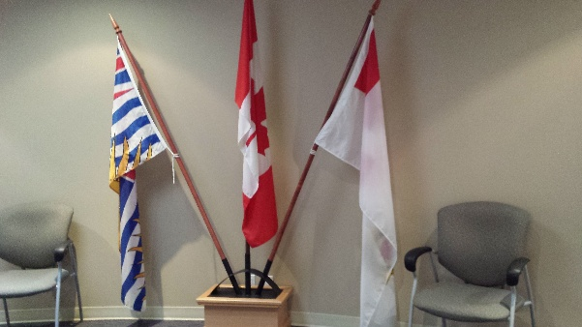
Picture that I took from my Dads work!
