The country of Italy

What is Italy known for?
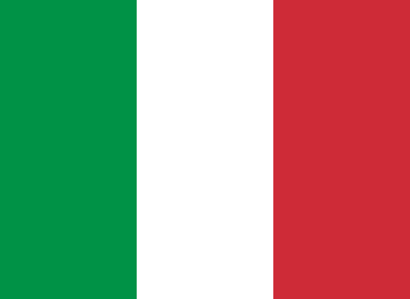
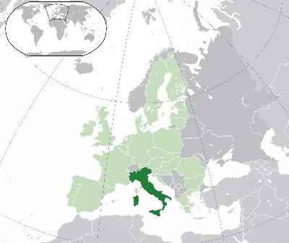
Italy is known for it’s great boot shaped country which is actually shaped as a boot. The amazing architecture from thousands of years ago. And what this beautiful place has to offer.

How is the economy in Italy?
Italy has the 3rd largest economy in Europe and the 8th largest in the world. Italy is considered one the world’s most industrialized nation and is leading in world trades and exports. Italy is also the 6th largest manufacturing company with very high quality products coming from companies like Ferrari.

What is Italy’s Geography

Geography
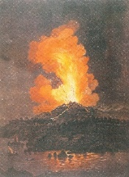
Italy stretches out a total 301,230 square kilometres and has a boot shaped peninsula. 40% of Italy is very Mountainous with the alps up north. On this area there are 14 volcanoes, 4 of them being active including Etna, the largest active volcano in Europe.

Climate
Weather condition of the Costal areas differ from higher ground. The Costal areas have mild winters and dry summers bug the higher area’s have cold winters and hot summers.

Why is Italy’s population?
Italy’s population is currently 60 million. The Capital of Italy, Rome has a population of 2.8 million. It’s the 23rd most populated area in the world!

How’s the food in Italy?
Italy’s food ranges from everyone’s favourite: Pizza with the many, many toppings you can put on it. Pasta with it’s delicious flavour that has been shared around the world. And Gelato, with it’s cool irresistible taste!

Tourist attractions?
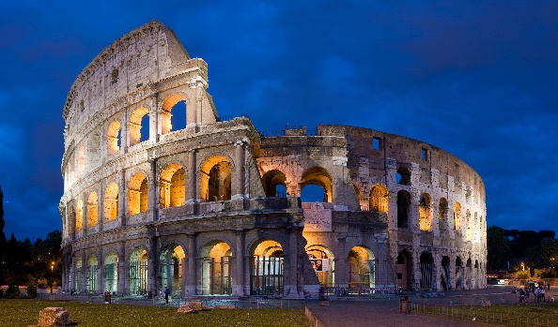
There are many places to visit in Italy. Ranging from the Colosseum built in 70–80 AD with it’s rich architecture. to the Pantheon built to honor Roman mythology. to the leaning tower of Pisa which is literally leaning!

Why Should I come to Italy?
Because Italy gives you what others can’t! With the many places you can go, to the amazing architecture Italy delivers to it’s original and irresistible food. It’s a vacation you will never forget and can’t get anywhere but here!

