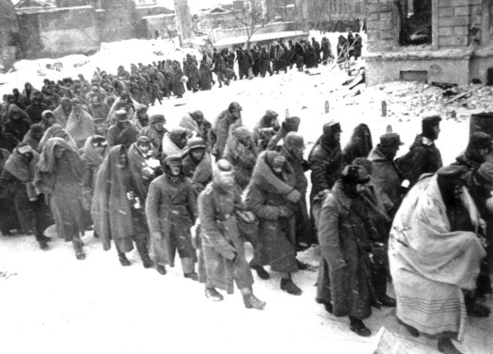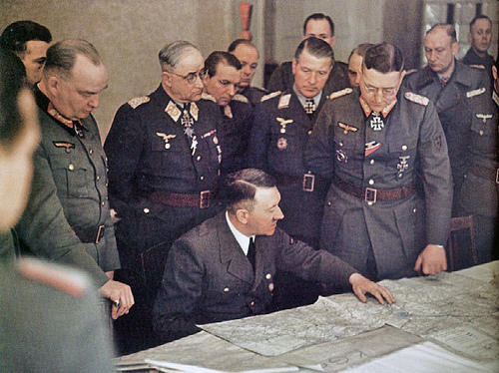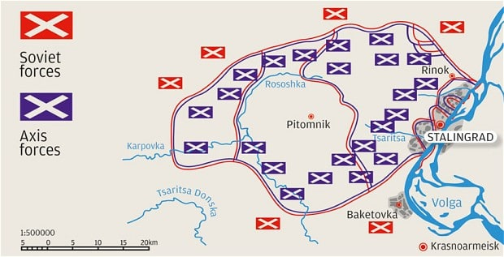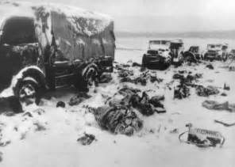[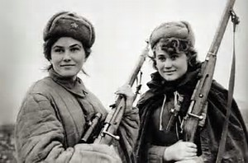](https://www.bing.com/images/search?view=detailV2&ccid=mwTvkB3%2b&id=2A86EF18D68F5117FC597578F865A3AD5E3EBA66&thid=OIP.mwTvkB3-GQwdvJgHMxD8IgEsDG&q=Stalingrad+women+snipers&simid=608016703591744511&selectedIndex=0)[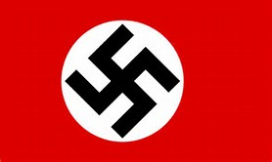](https://www.bing.com/images/search?view=detailV2&ccid=JkXZbeWi&id=69012A43231A7C9C40C242E113DE3801516F7CF4&thid=OIP.JkXZbeWiwyByfQbW7OWtzwEsCz&q=nazi+flag&simid=607989353211102971&selectedIndex=3)By Adam Weber

The Germans now had no supplies, where trapped, moral was low and they where freezing. While the German forces tried to get reinforcements, none could come, and the Germans surrendered in February of 1943, giving the people of Germany one of their first losses in world war 2. This loss allowed the soviet forces to push into German territory and attack berlin, bringing about the end of the war.

As the Germans where surrounded, the commander of the axis forces asked for permission to break out, but Hitler had just fired many of his generals, and he was making many calls himself. Hitler said do not break out, and he said the Luftwaffe would reinforce the axis power trapped inside, as the cut-off of any supplies. The reinforcement failed as the Luftwaffe lost many planes, and only a fraction of the supplies made it inside the city.

The Germans took many parts of the city, but the red army clung to the remints they still had. Red army troops where ferried across the Volga river to hold a section behind the German lines. The red army then targeted the Romanian fronts, destroying them, and the 2 soviet forces grouped up, surrounding the Nazi forces

The soviets and the Germans where locked in conflict as fighting was seemingly sudden and in close quarters. Both army’s optimized heavy machine guns and tanks, the soviets still clinging to Stalingrad’s factory district. After months of fighting like this, November came, and the Russian winter soon set in. it caused problems for both armies, breaking down tanks and jamming guns, but the Russians had an advantage as their clothes where warmer, and they didn’t make many foolish mistakes, like getting caught out in the cold.

As said before, Stalingrad was an extremely important position for the Soviets because if it was lost, the moral of the Russian people would drop. Because the city had Stalin’s name in it the Russian people did everything they could to defend it. unregistered men would form squads and fight, women and children dug trenches, and women where even used as artillery gunners and snipers.

The battle of Stalingrad was a successful defense of the Soviet city of Stalingrad in 1942. An important position to hold for the Soviet Union’s troops moral and the moral of the Russian people (because it shared Stalin’s name). it was a one of Nazi Germany’s first defeats and is considered one of the turning points of the war.

THE BATTLE OF STALINGRAD