All About Me
Name:
Block:
Culminating Project
CLE 10

You have completed several surveys which helped you determine your:

- LEARNING STYLE: discovering your learning style and understand how that affects how you learn and complete certain tasks and activities, both academically and in your personal life. This also gave you some insight into choosing the best study tip that will hopefully help you study in the future.
- PERSONALITY: discovering and understanding different factors that contribute to your personality and identifying your strengths and weaknesses so that you can increase your self-awareness.
- INTERESTS: reflecting upon your interests and learning how those interests relate to work. You were able to discover and explore different career opportunities that matched your interests.
- KNOWLEDGE BASE: reflecting on your own interests and learning how those interest relate to work. Exploring and discovering different career options that are related to your favourite subject areas.
- MOTIVATIONS: creating a goal and reflecting upon what will drive you to achieve that goal. Knowing what motivates you and becoming more aware of what you are looking for in a future career can be an important asset.

PART ONE: MAKING A SILHOUETTE POSTER:
You will be creating a silhouette of your head; within and around the outline you are to include the following:

- Your name in bold letters above the silhouette
- Within the silhouette
- Your “Learning Style” and your strongest “Multiple Intelligence”
- Minimum of 2 favourite subjects at school or what you enjoy learning about
- Minimum of 5 Adjectives describing yourself
- Around the silhouette
- Pictures/words showing your interests
- Your goal: illustrated and explained
- Possible Career options: illustrated and stated in words ie: If you would like to be a teacher have the words: Possible Careers or Careers? as a section and pictures of possible options under the topic heading

This is a visual project. Ensure your words are neatly written and large enough to be seen from a distance. There should be no visible pencil. Placement of words and images, as well as their proportions, should be considered.

PART TWO: CORE COMPETENCY REFLECTION:
You are to write a minimum 250 word reflection on how learning about all the various categories above (learning style, personality, interests, knowledge base, motivations) helped you grow in the areas of having a “Positive Personal Identity,” and the “Personal Awareness and Responsibility” Core Competencies.
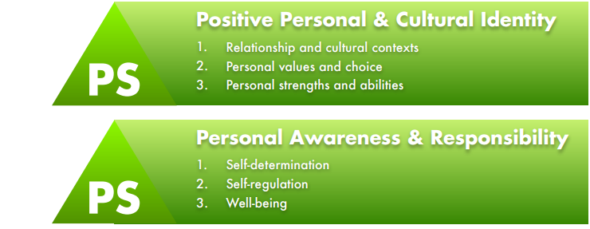
- Open either the Word doc or PDF version of the Core Competencies self-assessment. They can be found on your own blog or downloaded from my blog.

- Select PS (Personal and Social Competencies) on the left side by placing an X in the box.

- You are going to be writing about two or three of the following four “I can” or “I understand” statements, while keeping in mind the 250 word requirement which does not include the bolded statements provided. You need to write out the “I can” or “I understand” statement in bold in your document and then explain it based on what I’ve given you in the prompt; however, do NOT write the prompt itself in your document.

  - I can explain my learning style.
- Describe your learning style.
- What are some strategies you use to study when learning something new?
- What is your strongest multiple intelligence, and do you think it is accurate with what you believe to be true in your life?
- How will knowing your learning style/strongest multiple intelligence help you in your future?
- Will knowing your strengths in learning help you develop new abilities and strengths to help you meet new challenges?

Example of answering the first bullet of the “I can” statement:
I can explain my learning style as being a “hands-on” learner and “doing” rather than reading or listening to others. I like to be active, take several breaks when learning something new and I need to make gestures when I am speaking or explaining something to others. I really enjoy hands-on activities while learning as it engrains what I am doing into my memory at a much deeper level. I also appreciate getting encouragement from others while sharing what I have learned with others.

  - I understand that learning is continuous, and my concept of self and identity will continue to evolve.
- Describe how you know learning is a life-long process and how who you are as a person will also change as you mature throughout your life journey.
- Give an example of something you have been learning most of your life.
OR
- Give an example of something you learned and how it changed your self-perception.

  - I can identify/describe/express my individual characteristics, attributes, and skills.
- Describe your individual characteristics/attributes/skills.
- What are your strengths? How can you use them to help/benefit you?
- What are your weaknesses? How can you improve those weaknesses so they don’t hold you back?

  - I can reflect on my strengths and identify my potential as a leader in my community.
- After analyzing aspects of my learning style, personality, interests, motivations, and knowledge base, describe how those specific strengths can help you to be a leader/positive role model in your community.
- Which opportunities can you take to be a role model/leader in your school or community right now? (ex: volunteering at the seniors’ centre, helping run a school club, etc.)

PART THREE: PUBLISHING YOUR PROJECT AND SELF-ASSESSMENT
You will now embed the photo of your silhouette poster and self-assessment in the same edublog post. Make the post public unless you are uncomfortable having others see this information about you. If adding a password to your post, it needs to be ChapellCLE10.

- Start a new post on your edublog.
- Use the Add Document button located at the top of your post page and embed the picture of your silhouette (first) and your self-assessment (under the silhouette) in your blog post.
- Title: “All About Me” Project and Self-Assessment
- Categories: Self-Assessment and CLE 10
- Tags: Now tag your post using the following competencies that you have written about:
#personalidentitycc
#personalawarenesscc
- Publish!

*If your file size is too large to post, put the file into your One Drive account then embed it from there.

