Lab Safety Assignment
Part A: Map
Draw a map of the room and include the location of the doors, white board, windows, sinks and cabinets. Next, label the following items from the list on the map to indicate the location of all safety equipment in the room.
List:
- Fire extinguisher
- Fire blanket
- Nearest fume hood
- Broken glass container
- Gas and electrical shut-off valve
- Eye wash station
- Exit
Part B: Safety Rules
Use the Safety Rules sheet to answer the following questions in complete sentences.
- You knock over a test tube of liquid, which catches on fire on your table. What should you do?
__________________________________________________________________________________________________________________________________________________________________________
- a.) Your lab partner’s hair catches on fire during a lab, what should you do?
__________________________________________________________________________________________________________________________________________________________________________
b.) What could your partner have done to prevent this incident from happening?
__________________________________________________________________________________________________________________________________________________________________________
- Explain how you would safely heat a test tube with a chemical inside.
__________________________________________________________________________________________________________________________________________________________________________
- a.) As you are pouring a chemical into a test tube, some of it splashes into your partner’s eye. What should you do?
____________________________________________________________________________________________________________________________________________________________
- How could this incident have been prevented?
____________________________________________________________________________________________________________________________________________________________
Part C: Hazardous Household Product Symbols. a.)
- Identify the degree of hazard each shape represents. b.)

c.)
2. Identify the type of hazard each picture represents.

- Draw the following Hazardous Household Product Symbols

- Danger Flammable

- Warning Explosive

- Caution Poison

- Caution Corrosive

Part D: WHMIS
Record the names of the Workplace Hazardous Material Information System (WHMIS) symbols.

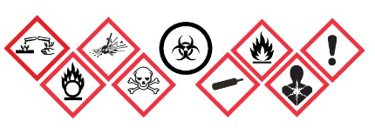

Part E: Safety Poster

Using the Safety Rules you have reviewed, draw a safety poster that could be displayed in the classroom to inform other of this important information.

